ALLIANCE UNIVERSITY
SCHOOL OF ADVANCED COMPUTING
DEPARTMENT OF COMPUTER APPLICATION
MASTER OF SCIENCE – DATA SCIENCE
2026–2028 BATCH
SEMESTER – I
DATA MODELLING AND VISUALIZATION
[COURSE CODE – CONFIRM]
MINI PROJECT REPORT
SURAT WEATHER INTELLIGENCE SYSTEM
Submitted By:
Name: Shubhang
Registration No.: 015
Date: 30-10-2026
Submitted To:
Faculty Name: [ENTER FACULTY NAME]
Department of Computer Application
School of Advanced Computing
Alliance University
Chandapura – Anekal Main Road, Anekal
Bengaluru – 562106

CERTIFICATE

This is to certify that the Mini Project work entitled “SURAT WEATHER INTELLIGENCE SYSTEM” is a bonafide work carried out by SHUBHANG, submitted towards the internal assessment requirements for the course Data Modelling and Visualization, Master of Science – Data Science, during the academic year 2026–2027.

Faculty Name: [ENTER FACULTY NAME]
Designation: [ENTER DESIGNATION]
Department of Computer Application
School of Advanced Computing
Alliance University

Signature of Faculty: __________________________
Date: __________________

ABSTRACT
The Surat Weather Intelligence System is a web-based meteorological monitoring and analytics application designed to present weather conditions for Surat, Gujarat through a consolidated dashboard. Weather information is relevant to daily planning, transport, outdoor activities, public services and local operational decisions. The system brings key atmospheric indicators—including temperature, feels-like temperature, humidity, barometric pressure, wind speed, wind direction, visibility and cloud cover—into a single interface. It also maintains historical records so users can inspect recent conditions and administrators can review system activity.
The supplied interface identifies a Node.js and Express backend, a MySQL 8.0 database and a browser-based dashboard. The overview page identifies OpenWeatherMap API as a weather-data source and displays telemetry synchronization controls. The application is divided into modules for overview, live weather, historical analytics, Power BI dashboard, weather records and administration. The workflow includes synchronizing weather telemetry, storing observations, retrieving records, calculating summary indicators and rendering charts and tables. No machine-learning prediction algorithm or model-training process is demonstrated in the screenshots; therefore, this report treats the project as a monitoring, data-management and visualization system rather than claiming predictive accuracy.
The captured dashboard state reports 65 persisted weather records, an average temperature of 29.76°C, a peak maximum temperature of 36.35°C, mean humidity of 60.29% and mean barometric pressure of 1011.12 hPa in the Power BI dashboard. The live-weather page shows 31.50°C with Clear Sky, feels-like temperature of 33.25°C, humidity of 49%, pressure of 1013 hPa, wind speed of 1.58 m/s and visibility of 10.0 km. These are time-specific screenshot values, not permanent climate statistics.

TABLE OF CONTENTS
Abstract
1. Introduction
1.1 Background
1.2 Problem Statement
1.3 Aim and Objectives
1.4 Scope of the Project
2. Literature Review
3. Proposed System Architecture
3.1 System Overview
3.2 Application and Data Layers
3.3 Functional Modules
3.4 Database and Data Fields
4. Methodology and Implementation
4.1 Development Environment and Approach
4.2 Weather Data Acquisition and Synchronization
4.3 Data Storage and Record Management
4.4 Dashboard and Visualization Implementation
4.5 Administrative and Audit Functions
5. Results, Testing and Discussion
5.1 Overview Dashboard
5.2 Live Weather Module
5.3 Historical Weather Records
5.4 Power BI Dashboard
5.5 Administration and Audit Console
5.6 Functional Testing Summary
6. Conclusion and Future Enhancements
7. References

1. INTRODUCTION

1.1 Background
Weather conditions influence everyday and operational decisions. Temperature, humidity, atmospheric pressure, wind and visibility can affect travel, outdoor work, public events and local planning. Although weather information is available from online services, users may find it difficult to compare current conditions with earlier observations or review the history collected for a particular location. The Surat Weather Intelligence System addresses this need by presenting current weather telemetry and stored observations through a single web application. The screenshots show Surat, Gujarat, India, with station coordinates displayed as approximately 21.1702° N and 72.8311° E.

1.2 Problem Statement
Weather values presented as isolated readings provide limited analytical context. Without historical storage, users cannot easily inspect changes over time, compare atmospheric variables or verify when observations were synchronized. The problem addressed is to develop a location-focused weather information system that organizes live and historical observations and presents them through understandable visualizations, while providing record-management and administrative audit capabilities.

1.3 Aim and Objectives
Aim: To design and implement a web-based weather monitoring and visualization system for Surat that stores weather observations and presents current and historical meteorological information through an interactive dashboard.
- Display current weather conditions and key atmospheric measurements.
- Synchronize weather telemetry from the configured weather-data source and show synchronization status.
- Persist weather observations in a MySQL relational database.
- Provide searchable and paginated weather records with condition and date filters.
- Visualize weather trends and aggregated indicators using charts and a Power BI dashboard page.
- Provide an administrative interface for user governance, record pruning and audit-log inspection.

1.4 Scope of the Project
The scope, based on the supplied interface evidence, includes Surat-focused weather monitoring, telemetry synchronization, historical record storage, data visualization, record filtering/export controls and administrative audit functions. The screenshots identify Node.js, Express and MySQL 8.0 as backend technologies and identify OpenWeatherMap API in the overview interface. Physical weather sensors, a trained forecasting model, a mobile application and a production cloud deployment are not assumed because these are not established by the screenshots. The displayed values represent the captured application state on 30 October 2026 and are not treated as long-term climate statistics.

2. LITERATURE REVIEW
Weather monitoring and visualization systems commonly combine data acquisition, structured storage and visual presentation. A dashboard is useful when it transforms individual measurements into summaries and trends without hiding the underlying observations. The following concepts provide the technical foundation for this project.

2.1 Weather Data Services and APIs
Weather APIs provide programmatic access to meteorological observations and related conditions. An application can request data for a location, parse returned fields and map them into a consistent internal representation. The project overview identifies OpenWeatherMap API as a source. A robust implementation should validate responses, handle missing fields, record retrieval timestamps and distinguish observation time from fetch time.

2.2 Relational Database Management
A relational database is suitable for structured observations because each record can be stored with a unique identifier, timestamp, weather condition and numeric measurements. MySQL supports structured queries, filtering, sorting, aggregation and constraints. The Weather Records page labels its table weather_records and reports 65 total entries in the captured state. The administration screen also refers to a system_logs table for audit events.

2.3 Data Visualization and Business Intelligence
Time-series charts reveal how a measurement changes across observation times. Summary cards communicate aggregated values such as average temperature or mean humidity, while multi-series charts compare variables with different units. The project includes a Power BI dashboard page with temperature trend and humidity-pressure comparison visuals, along with an overview chart for recent telemetry observations.

2.4 Web Application Architecture
A web application commonly separates the user interface, server-side application logic and persistent data layer. Node.js provides a JavaScript runtime for server-side code, Express is a web framework for routing and middleware, and MySQL provides persistent relational storage. The browser requests data through application routes, the server performs validation and database operations, and the interface renders the resulting information.

2.5 Administrative Accountability
Administrative functions are important in systems that allow users to export or delete records. Role-based access can restrict sensitive operations to authorized users, while audit logs can record actor, action, timestamp and description. The supplied Admin Panel shows ADMIN and VIEWER roles, a record-pruning form and a chronological system_logs table. The interface states that deletions are logged permanently.

3. PROPOSED SYSTEM ARCHITECTURE

3.1 System Overview
The system follows a browser–server–database structure. A user accesses the application through a browser. The frontend presents dashboard pages and sends requests to the backend. The Node.js/Express backend coordinates weather-data synchronization, validation, database access and response formatting. MySQL stores weather observations and system audit records. The overview page identifies OpenWeatherMap API as the external weather-data source.
- Weather data is obtained from the configured source or telemetry synchronization process.
- The application maps returned measurements into the weather-record structure.
- Validated observations are stored in the MySQL weather_records table.
- Dashboard routes retrieve current and historical values from the backend.
- The frontend displays KPI cards, charts, searchable tables and administrative information.
- Administrative operations are recorded in the system_logs audit table.

3.2 Application and Data Layers
Layer | Responsibility | Evidence in interface
Presentation | Browser pages, navigation, KPI cards, charts, forms and tables. | Overview, Live Weather, Historical Analytics, Power BI, Weather Records and Admin Panel.
Application | Request handling, synchronization, filtering, aggregation, role checks and audit operations. | Backend identifies Node.js / Express.
Data | Persistent storage and retrieval of observations and audit events. | MySQL 8.0; weather_records and system_logs labels.
External source | Weather information supplied to the application. | OpenWeatherMap API label and telemetry controls.

3.3 Functional Modules
Module | Main functions
Overview | Consolidated current-weather summary, atmospheric indicators, recent telemetry trend and recent logs.
Live Weather | Temperature, feels-like value, wind vector, humidity, cloud density, pressure, visibility and astronomical information.
Historical Analytics | Area for examining historical weather patterns and changes over time.
Power BI Dashboard | Aggregated KPIs and visual comparisons for temperature, humidity and pressure.
Weather Records | Searchable, paginated table with condition/date filters and filtered-data export.
Admin Panel | Registered users and roles, backend health, record-pruning controls and system activity logs.

3.4 Database and Data Fields
The Weather Records page visibly presents the following fields. The physical SQL schema was not supplied, so this table describes fields exposed by the interface rather than claiming an exact CREATE TABLE definition.
Field shown | Meaning / unit
Record ID | Unique identifier for each stored observation.
Observation Time (IST) | Date and time associated with the observation.
Condition | Weather category such as Clear, Haze or Clouds.
Temperature | Air temperature in °C.
Feels Like | Apparent temperature in °C.
Humidity | Relative humidity percentage.
Pressure | Atmospheric pressure in hPa.
Wind Speed | Wind speed in m/s; direction is shown in degrees.
Visibility | Visibility distance in kilometres.

The administration screen additionally identifies system_logs and displays log ID, timestamp (IST), action, description and user. This supports traceability of synchronization and administrative events.

4. METHODOLOGY AND IMPLEMENTATION

4.1 Development Environment and Approach
The supplied interface identifies a Node.js and Express backend connected to MySQL 8.0. The application is accessed locally through a browser at localhost:5173 in the screenshots. The implementation is described in terms of visible modules and behaviour; source code and configuration files were not included with the screenshots, so exact package versions, API endpoints and database DDL are not asserted.
- Configure the target location and weather-data source.
- Retrieve or synchronize the latest weather information.
- Validate the response and map fields into the weather-record format.
- Persist observations in MySQL with an associated timestamp.
- Query the database to populate summaries, historical charts and paginated records.
- Provide filters and export options for subsets of the dataset.
- Record synchronization and administrative actions in the audit log.

4.2 Weather Data Acquisition and Synchronization
The dashboard contains a Sync Telemetry control and an Online indicator. The Live Weather page includes an Immediate Sync control. The overview identifies Live Sensor Data and OpenWeatherMap API as source/status labels, while the live page labels telemetry ingestion as Real-Time Telemetry. The Admin Panel log shows WEATHER_REFRESH events and a CRON_INGESTION event described as an automatic 10-minute observation record. A recommended acquisition workflow is to request the latest observation, validate the response, normalize units and condition labels, attach a timestamp and insert the observation. The screenshots demonstrate synchronization controls and logged refresh activity, but do not expose the exact API request code or retry policy.

4.3 Data Storage and Record Management
The Weather Records page is described as a searchable, paginated relational table directly connected to MySQL. In the captured state, it reports 65 total entries and shows page 1 of 5. Users can search by description, select a weather condition and specify a date range. An Export Filtered Dataset control is available. The Admin Panel provides a form to delete a specific observation by Weather Record ID. For reliable management, identifiers should be unique, timestamps should use a consistent time-zone policy, and numeric measurements should use numeric database columns. Deletion should require authorization and be recorded in an audit log.

4.4 Dashboard and Visualization Implementation
- KPI cards communicate average temperature, peak maximum temperature, mean humidity and mean barometric pressure.
- A time-series chart displays temperature trends over recent dates or observation times.
- A multi-series chart compares humidity percentage and pressure in hPa.
- A telemetry trend chart provides a recent-observation view with selectable weather parameters.
- A relational table exposes individual records for searching, filtering, pagination and export.
The Power BI page shows two named visuals: Temperature Diurnal Trend & Variance, and Relative Humidity & Atmospheric Pressure. The temperature chart uses daily aggregated average temperature across 23–30 October in the captured screenshot. The second chart compares humidity and pressure over the displayed dates. The page includes Configure Embed URL and Export Power BI CSV controls.

4.5 Administrative and Audit Functions
The Admin Panel is labelled System Administration & Audit Console. It displays two registered users in the captured state: one ADMIN and one VIEWER. It also shows latest synchronization telemetry, backend server status and a record-pruning panel. The audit table contains chronological events such as WEATHER_REFRESH and CRON_INGESTION, with descriptions and user identities. The interface states that deletion operations are logged permanently with administrator identity.

5. RESULTS, TESTING AND DISCUSSION
This chapter interprets the actual values and interface behaviour visible in the six supplied screenshots. Values are reported as they appear in the captured state on 30 October 2026. Since screenshots are snapshots, they should not be interpreted as continuous measurements or long-term climate averages.

5.1 Overview Dashboard
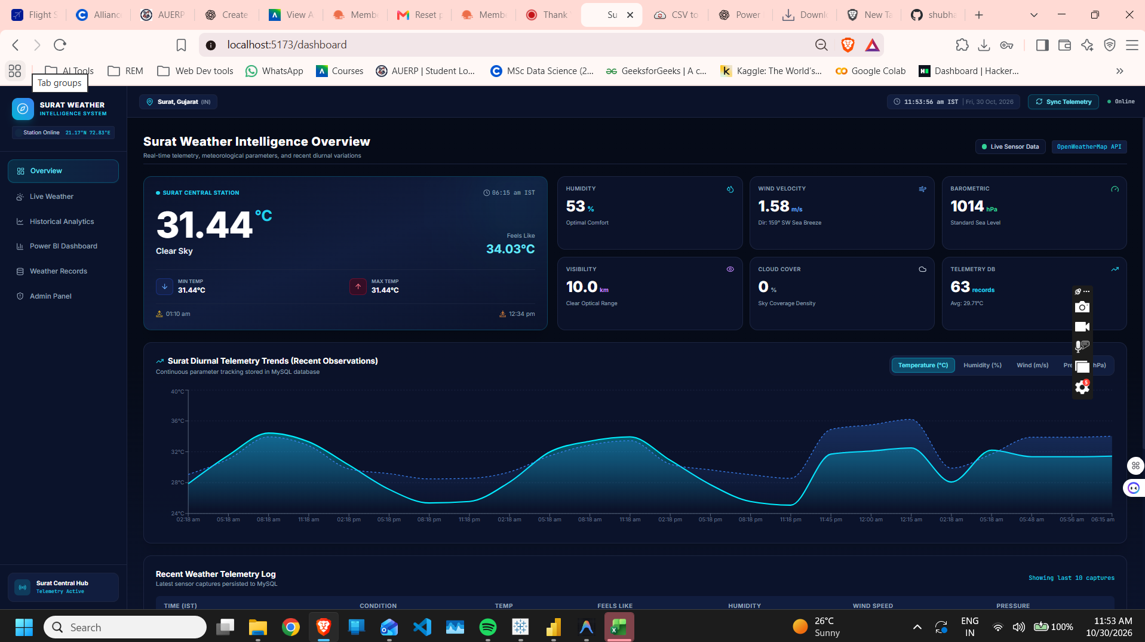
Figure 5.1: Surat Weather Intelligence Overview dashboard.
The overview dashboard provides a consolidated view of Surat Central Station. The captured card shows 31.44°C and a feels-like value of 34.03°C at approximately 06:15 AM IST. Other indicators include humidity of 53%, wind velocity of 1.58 m/s, barometric pressure of 1014 hPa, visibility of 10.0 km and cloud cover of 0%. The telemetry database card reports 63 records and an average of 29.71°C. A recent-observation chart plots temperature across multiple timestamps, while a recent telemetry log appears below the chart. This page combines current conditions, secondary measurements and recent history.

5.2 Live Weather Module
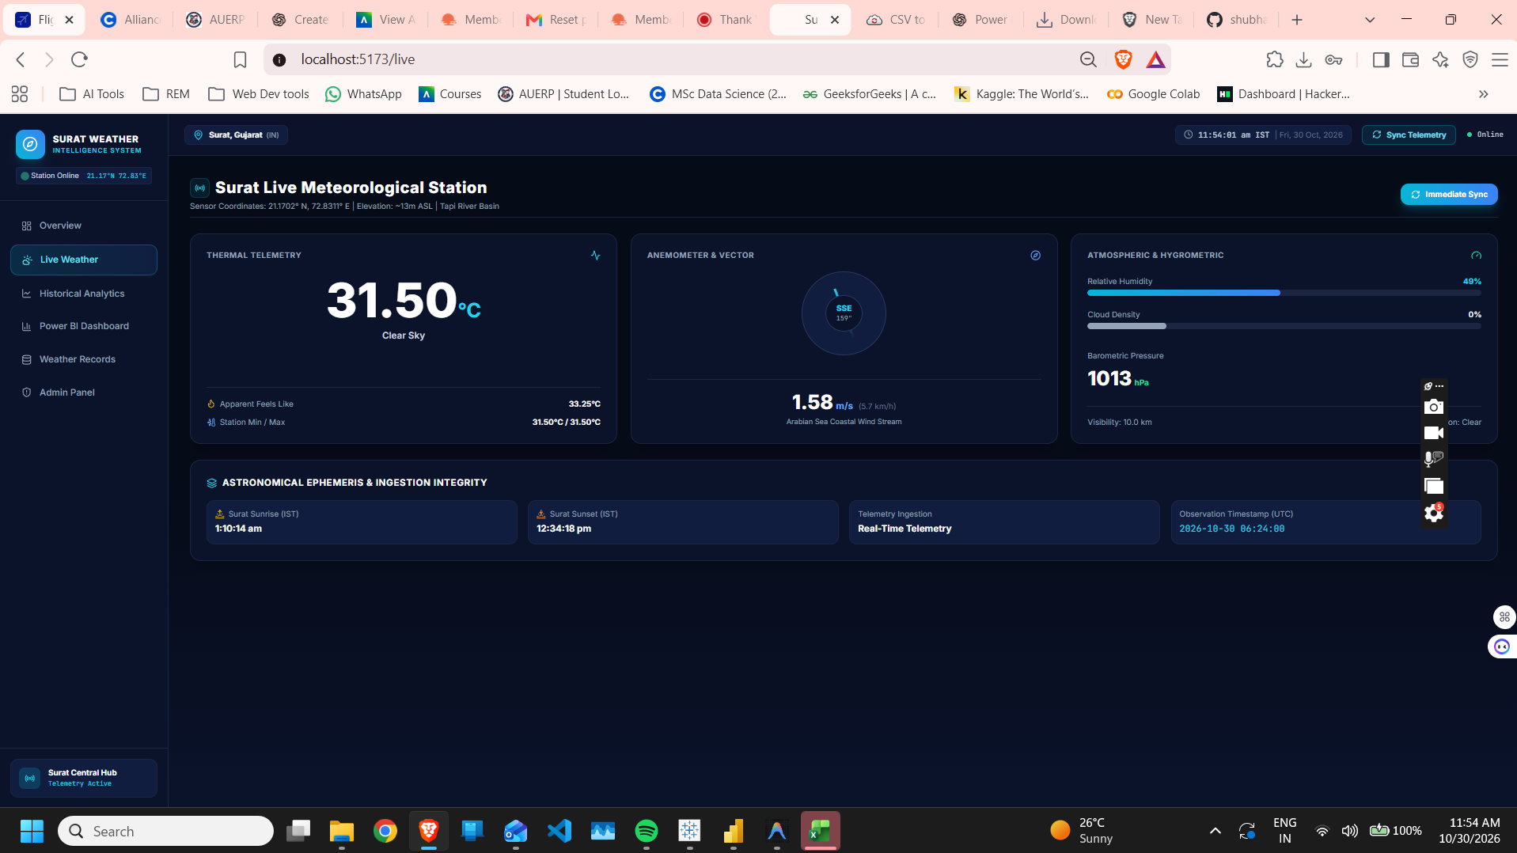
Figure 5.2: Live meteorological station page showing current telemetry.
The live page reports 31.50°C and Clear Sky. The apparent feels-like temperature is 33.25°C. Wind speed is 1.58 m/s and direction is SSE at 159°. Relative humidity is 49%, cloud density is 0%, barometric pressure is 1013 hPa and visibility is 10.0 km. The page also displays sunrise and sunset information, a real-time telemetry ingestion label and an observation timestamp in UTC. It separates thermal telemetry, wind vector and atmospheric/hygrometric measurements into dedicated panels.

5.3 Historical Weather Records
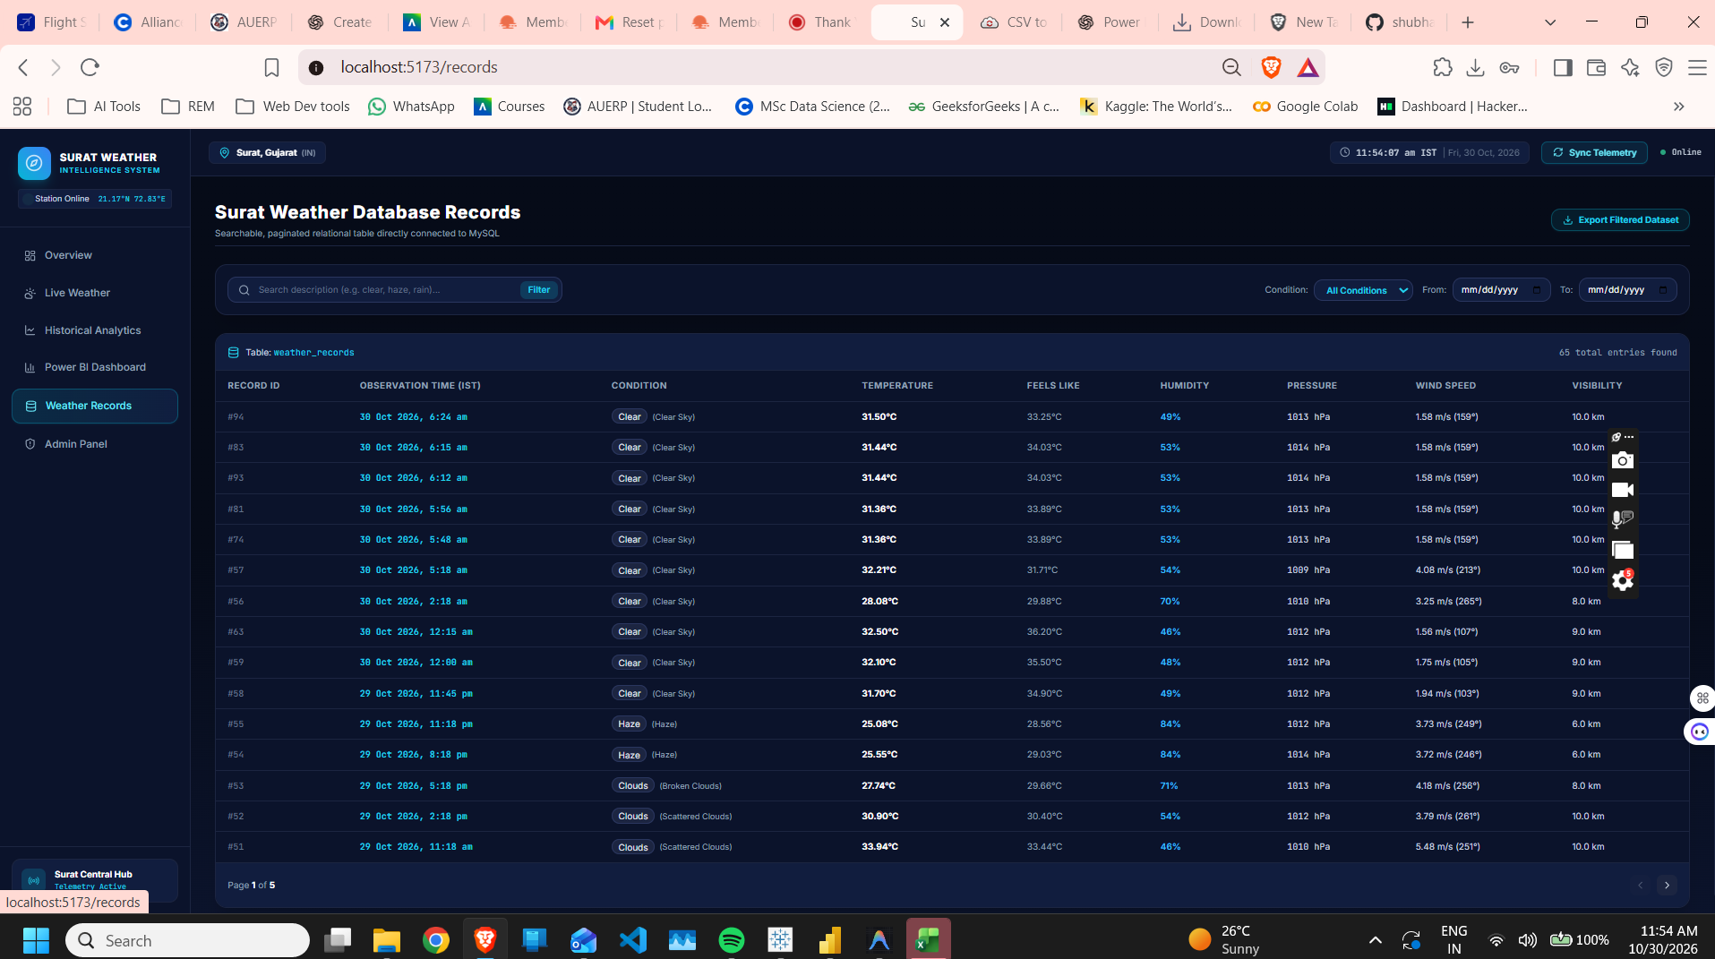
Figure 5.3: Searchable and paginated MySQL weather records page.
The records page labels its source table as weather_records and reports 65 total entries found. The visible table includes record ID, observation time, condition, temperature, feels-like temperature, humidity, pressure, wind speed and visibility. The filter strip provides description search, condition selection and From/To date controls. Pagination shows page 1 of 5. Visible rows include Clear, Haze and Clouds observations from 29 and 30 October 2026. This page provides record-level transparency and lets users inspect observations behind dashboard summaries.

5.4 Power BI Dashboard
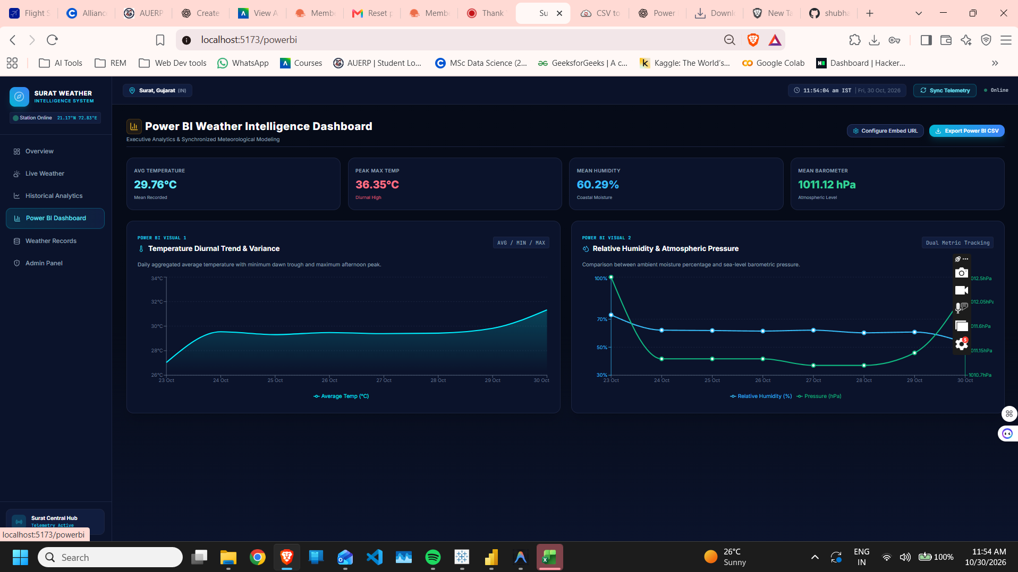
Figure 5.4: Power BI Weather Intelligence Dashboard with KPI cards and two analytical visuals.
Metric | Displayed value | Interpretation
Average Temperature | 29.76°C | Mean recorded temperature in the selected dashboard dataset.
Peak Max Temp | 36.35°C | Highest maximum temperature reported by the dashboard.
Mean Humidity | 60.29% | Average relative humidity across selected records.
Mean Barometer | 1011.12 hPa | Average atmospheric pressure across selected records.

The Temperature Diurnal Trend & Variance visual plots daily average temperature from 23 October to 30 October. It rises from approximately 27°C on 23 October to around 29.5°C on 24 October, remains comparatively stable for several days, and rises again near 30 October. The Relative Humidity & Atmospheric Pressure visual compares humidity and pressure across the same dates. Since the two series use different scales, each should be interpreted using its own axis. KPI cards provide numerical summaries while charts reveal changes over time.

5.5 Administration and Audit Console
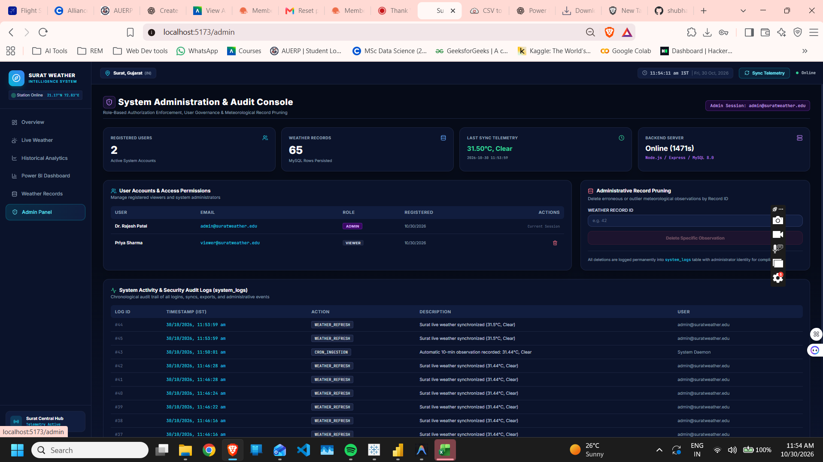
Figure 5.5: System Administration & Audit Console.
The Admin Panel reports two registered users and 65 weather records. The latest synchronization card displays 31.50°C, Clear, with a timestamp. The backend server card reports Online and identifies Node.js / Express / MySQL 8.0. The user table shows ADMIN and VIEWER roles. A record-pruning form accepts a Weather Record ID, and the system activity table lists timestamped actions including WEATHER_REFRESH and CRON_INGESTION. The audit table provides evidence of background ingestion and manual synchronization activity.

5.6 Functional Testing Summary
The following checks are based on visible interface evidence. They are not a substitute for automated unit tests, API integration tests or a security audit.
Test area | Observed evidence | Screenshot-based result
Dashboard rendering | Overview displays weather cards and telemetry trend. | Displayed successfully.
Live telemetry | Live page shows temperature, humidity, pressure, wind and visibility. | Displayed successfully.
Historical records | weather_records shows 65 entries and page 1 of 5. | Records presented in a paginated table.
Filtering controls | Search, condition and date-range controls are visible. | Controls are present; execution not shown.
Power BI visuals | Two charts and four KPI cards are visible. | Visuals rendered with aggregate values.
Administration | Two users, backend status and pruning form are visible. | Administrative interface rendered.
Audit logging | WEATHER_REFRESH and CRON_INGESTION appear in system_logs. | Events visible in audit table.

The screenshots do not provide evidence of API failure handling, concurrent-user load testing, data-validation edge cases, backup/restore testing, formal role-bypass testing or measured system latency. These should be tested before production use.

6. CONCLUSION AND FUTURE ENHANCEMENTS

6.1 Conclusion
The Surat Weather Intelligence System demonstrates a dashboard-oriented workflow for presenting current weather conditions and reviewing stored observations. Its interface brings together an overview dashboard, detailed live-weather page, historical records, a Power BI analytics page and an administrative audit console. The captured application state reports 65 weather records and displays summary indicators such as average temperature, peak maximum temperature, mean humidity and mean barometric pressure.
The project illustrates the value of combining structured data storage with visualization. KPI cards make key measurements easy to scan, time-series charts show how weather variables change across the selected period, and the records table allows inspection of individual observations. The administrative interface adds basic user governance and audit visibility. Based on the evidence provided, the system is characterized as a weather monitoring, record-management and visualization application; no forecasting accuracy or machine-learning performance is claimed.

6.2 Limitations
- The screenshots show a limited captured dataset and do not establish long-term data completeness.
- Source code, API response samples and the complete SQL schema were not supplied.
- No model-training workflow or forecast accuracy evaluation is demonstrated.
- Security controls, backup procedures, API failure handling and load testing are not verified by the screenshots.
- Displayed measurements are time-dependent and may change after synchronization.

6.3 Future Enhancements
- Add a documented database schema with indexes, constraints and retention policies.
- Implement API timeout handling, retries, rate-limit management and stale-data indicators.
- Add data-quality checks for missing, duplicated, out-of-range or inconsistent observations.
- Introduce configurable alerts for thresholds such as high temperature or low visibility, where source data is available.
- Extend historical analysis with weekly/monthly summaries, seasonal comparisons and anomaly detection.
- Evaluate forecasting models only after collecting a sufficiently large, validated time series; report MAE, RMSE or other suitable metrics on held-out data.
- Add automated tests for authentication, role permissions, deletion, filtering, export and API integration.
- Deploy with HTTPS, environment-based secrets, database backups, monitoring and a documented recovery procedure.

7. REFERENCES
[1] OpenWeather. OpenWeather API Documentation. https://openweathermap.org/api
[2] Node.js. Node.js Documentation. https://nodejs.org/docs/
[3] Express.js. Express – Node.js Web Application Framework. https://expressjs.com/
[4] MySQL. MySQL 8.0 Reference Manual. https://dev.mysql.com/doc/refman/8.0/en/
[5] Microsoft. Power BI Documentation. https://learn.microsoft.com/power-bi/
[6] Microsoft. Power BI Embedded Analytics Documentation. https://learn.microsoft.com/power-bi/developer/embedded/
[7] Alliance University. M.Sc. Micro-Project Report Format, supplied course document, 2026.
— END OF REPORT —

